from google.colab import files

uploaded = files.upload()

----------------------------------------------

from zipfile import ZipFile

# Unzip fake.csv

with ZipFile("fake.csv (1).zip", 'r') as zip_ref:

    zip_ref.extractall("/content/fake_news")

# Unzip true.csv

with ZipFile("true.csv.zip", 'r') as zip_ref:

    zip_ref.extractall("/content/true_news")

-----------------------------------------------------------  
import pandas as pd

# Load the CSVs

fake_df = pd.read_csv('/content/fake_news/fake.csv')

true_df = pd.read_csv('/content/true_news/true.csv')

# Add labels: 1 = Fake, 0 = Real

fake_df['label'] = 1

true_df['label'] = 0

# Combine datasets

data = pd.concat([fake_df, true_df], ignore_index=True)

# Shuffle the dataset

data = data.sample(frac=1, random_state=42).reset_index(drop=True)

# Check basic info

print("Shape of dataset:", data.shape)

data.head()

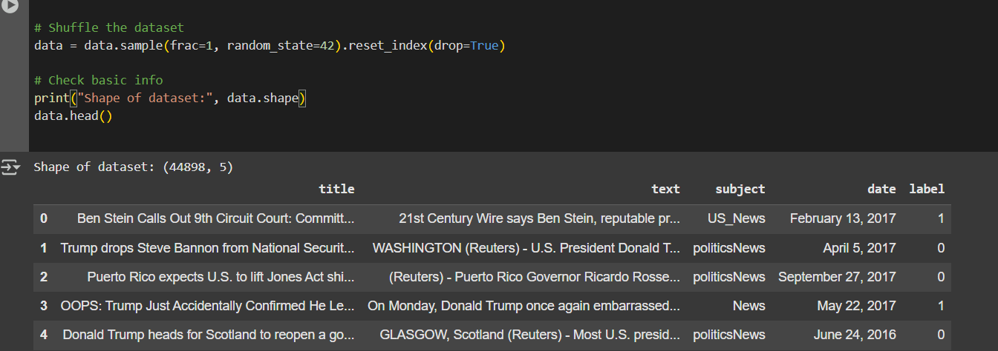

import re

import nltk

from nltk.corpus import stopwords

from nltk.stem import WordNetLemmatizer

# Download NLTK resources

nltk.download('stopwords')

nltk.download('wordnet')

nltk.download('omw-1.4')

stop_words = set(stopwords.words('english'))

lemmatizer = WordNetLemmatizer()

# Function to clean text

def clean_text(text):

    text = str(text).lower()

    text = re.sub(r'[^a-zA-Z\s]', '', text)       # Remove punctuation and numbers

    tokens = text.split()

    tokens = [lemmatizer.lemmatize(word) for word in tokens if word not in stop_words and len(word) > 2]

    return ' '.join(tokens)

# Apply to the text column (combine title + text if both exist)

if 'title' in data.columns and 'text' in data.columns:

    data['content'] = data['title'].fillna('') + " " + data['text'].fillna('')

else:

    data['content'] = data['text']

data['clean_content'] = data['content'].apply(clean_text)

# Preview cleaned data

data[['label', 'clean_content']].head()

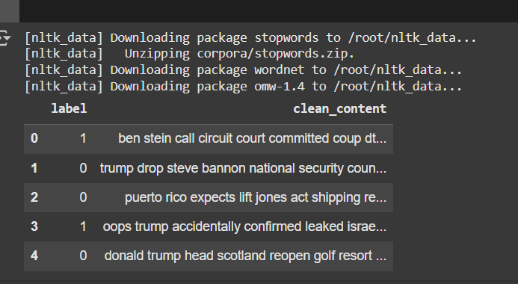

from sklearn.feature_extraction.text import TfidfVectorizer

# TF-IDF Vectorization

tfidf = TfidfVectorizer(max_features=5000)

X = tfidf.fit_transform(data['clean_content']).toarray()

# Labels

y = data['label'].values

print("TF-IDF shape:", X.shape)



import tldextract

# Example: A simple source credibility scoring function

# You can improve this with more sophisticated logic based on your dataset

def extract_source(text):

    # Try to extract the domain from the source text

    try:

        extracted = tldextract.extract(text)

        return extracted.domain

    except:

        return ""

def assign_credibility_score(domain):

    credible_sources = ['bbc', 'reuters', 'nytimes', 'guardian', 'cnn']

    if any(cred in domain for cred in credible_sources):

        return 1  # Credible source

    else:

        return 0  # Non-credible source

# Assuming 'source' column exists, if not we simulate with domain info.

data['source'] = data['content'].apply(lambda x: extract_source(x))

# Apply credibility scoring

data['credibility'] = data['source'].apply(assign_credibility_score)

# Preview the data with added source and credibility

data[['label', 'content', 'source', 'credibility']].head()

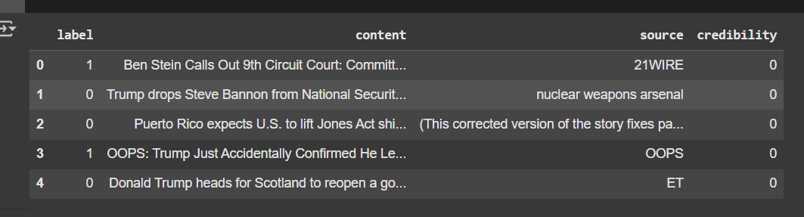

!pip install tldextract

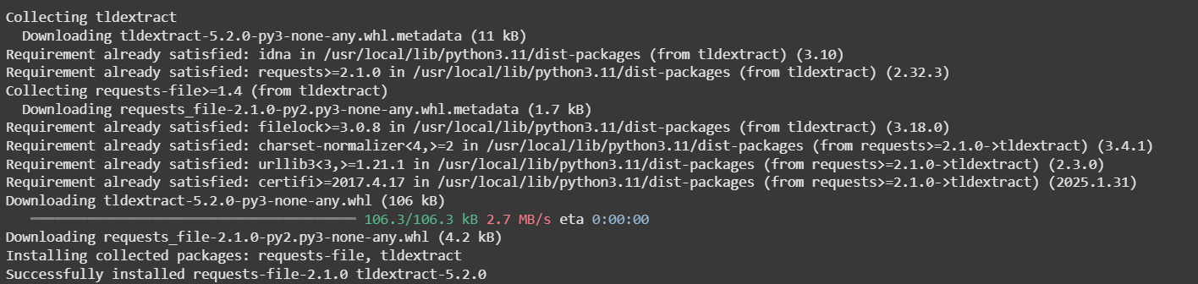

import tensorflow as tf

from tensorflow.keras import layers, models

from sklearn.model_selection import train_test_split

# Set random seed for reproducibility

tf.random.set_seed(42)

# Split data into training and test sets

X_train, X_test, y_train, y_test = train_test_split(X, y, test_size=0.2, random_state=42)

# Generator Model (Fake News Generator)

def build_generator(input_dim):

    model = models.Sequential()

    model.add(layers.Dense(128, activation='relu', input_dim=input_dim))

    model.add(layers.Dense(256, activation='relu'))

    model.add(layers.Dense(512, activation='relu'))

    model.add(layers.Dense(input_dim, activation='sigmoid'))

    return model

# Discriminator Model (Fake News Classifier)

def build_discriminator(input_dim):

    model = models.Sequential()

    model.add(layers.Dense(512, activation='relu', input_dim=input_dim))

    model.add(layers.Dense(256, activation='relu'))

    model.add(layers.Dense(128, activation='relu'))

    model.add(layers.Dense(1, activation='sigmoid'))

    return model

# Build GAN model (combined Generator + Discriminator)

def build_gan(generator, discriminator):

    discriminator.trainable = False

    model = models.Sequential()

    model.add(generator)

    model.add(discriminator)

    return model

# Initialize generator and discriminator

generator = build_generator(input_dim=X_train.shape[1])

discriminator = build_discriminator(input_dim=X_train.shape[1])

# Compile discriminator

discriminator.compile(optimizer='adam', loss='binary_crossentropy', metrics=['accuracy'])

# Build and compile GAN model

gan = build_gan(generator, discriminator)

gan.compile(optimizer='adam', loss='binary_crossentropy')

# Summary of the models

generator.summary()

discriminator.summary()

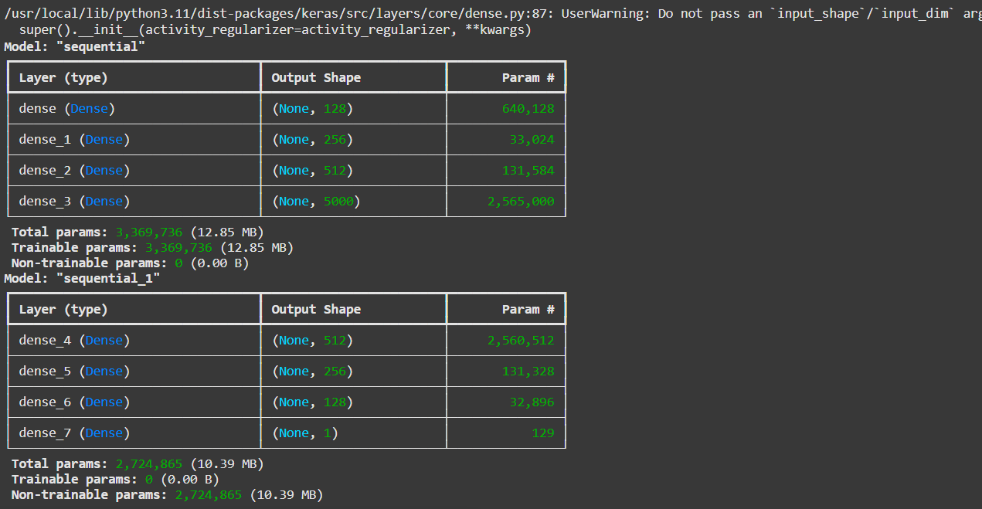

import numpy as np

# Training function

def train_gan(generator, discriminator, gan, X_train, y_train, epochs=1000, batch_size=64):

    for epoch in range(epochs):

        # 1. Train the Discriminator

        idx = np.random.randint(0, X_train.shape[0], batch_size)

        real_data = X_train[idx]

        real_labels = y_train[idx]

        fake_data = generator.predict(np.random.randn(batch_size, X_train.shape[1]))

        fake_labels = np.zeros(batch_size)  # Fake news has label 0

        d_loss_real = discriminator.train_on_batch(real_data, real_labels)

        d_loss_fake = discriminator.train_on_batch(fake_data, fake_labels)

        d_loss = 0.5 * np.add(d_loss_real, d_loss_fake)

        # 2. Train the Generator

        noise = np.random.randn(batch_size, X_train.shape[1])

        valid_labels = np.ones(batch_size)  # Generator tries to make fake data appear real

        g_loss = gan.train_on_batch(noise, valid_labels)

        if epoch % 100 == 0:

            print(f"{epoch} [D loss: {d_loss[0]} | D accuracy: {100 * d_loss[1]}] [G loss: {g_loss}]")

# Start training the GAN

train_gan(generator, discriminator, gan, X_train, y_train, epochs=1000, batch_size=64)

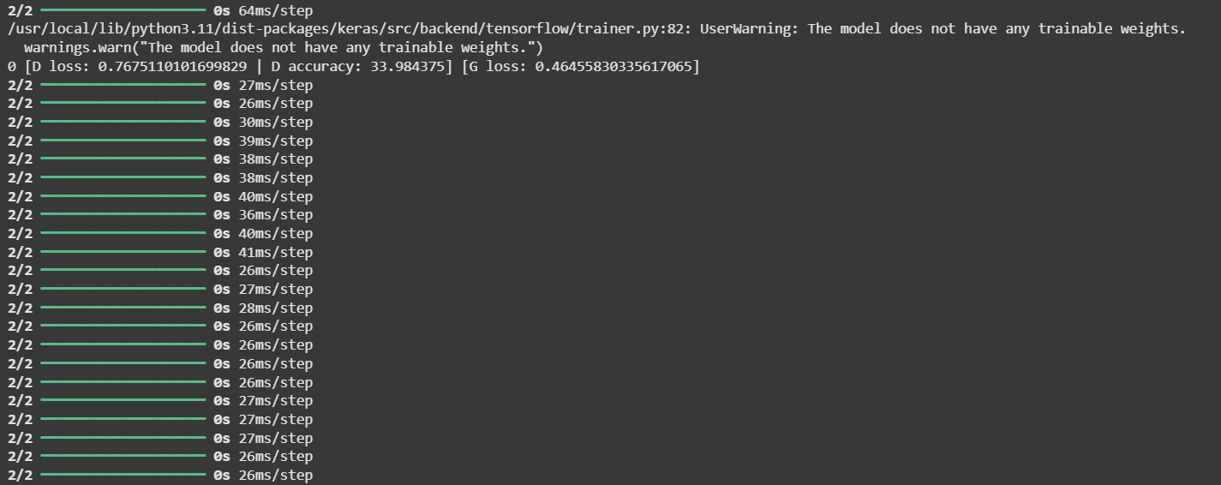

 #Assuming we have a credibility score function for each article

def get_credibility_score(article):

    # Simple example: You can expand this with more sophisticated logic

    # If the source is from a high-credibility domain (example: cnn.com, bbc.com, etc.), assign a high score

    high_cred_sources = ['cnn.com', 'bbc.com', 'nytimes.com']

    # Example: Extract the source domain from the URL (you can also use other source metadata)

    domain = tldextract.extract(article)

    source = domain.domain + '.' + domain.suffix

    if source in high_cred_sources:

        return 1  # High credibility

    else:

        return 0  # Low credibility

# Example final prediction logic combining both

def final_prediction(discriminator_output, article):

    credibility_score = get_credibility_score(article)

    # Weights: Give more weight to content if the source is credible

    if credibility_score == 1:

        final_decision = discriminator_output * 0.7 + credibility_score * 0.3  # More focus on discriminator for credible sources

    else:

        final_decision = discriminator_output * 0.5 + credibility_score * 0.5  # Equal weight for fake and non-credible sources

    # If final decision is closer to 1, classify as real (real news), if closer to 0, classify as fake

    return 1 if final_decision > 0.5 else 0

# Example: Using the trained discriminator to predict and then combining with SCS

def predict_fake_news_with_scs(article_text):

    # Step 1: Use the discriminator model to classify the article as real (1) or fake (0)

    article_vector = tfidf.transform([article_text]).toarray()  # Transform the text to TF-IDF features

    discriminator_output = discriminator.predict(article_vector)

    # Step 2: Combine with SCS to make final decision

    final_decision = final_prediction(discriminator_output, article_text)

    return final_decision

# Test with an example article

example_article = "This is a sample news article about recent political developments."

prediction = predict_fake_news_with_scs(example_article)

print("Final Prediction (1 = Real, 0 = Fake):", prediction)



from sklearn.model_selection import train_test_split

X_train, X_test, y_train, y_test = train_test_split(

    X, y, test_size=0.2, stratify=y, random_state=42

)

print("Train:", sum(y_train==1), "Fake,", sum(y_train==0), "Real")

print("Test :", sum(y_test==1), "Fake,", sum(y_test==0), "Real")

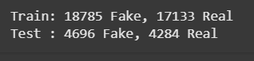

from sklearn.ensemble import RandomForestClassifier

from sklearn.metrics import classification_report, confusion_matrix, accuracy_score

# Train the classifier

clf = RandomForestClassifier(n_estimators=100, random_state=42)

clf.fit(X_train, y_train)

# Predict and evaluate

y_pred = clf.predict(X_test)

print("Accuracy:", accuracy_score(y_test, y_pred))

print(classification_report(y_test, y_pred))

print("Confusion Matrix:\n", confusion_matrix(y_test, y_pred))

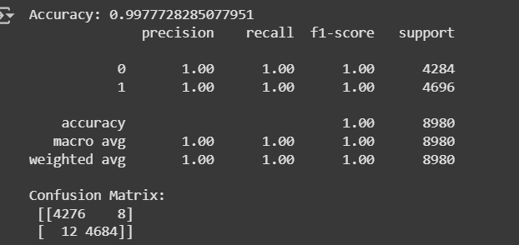

import joblib

joblib.dump(clf, 'fake_news_model.pkl')



!pip install lime --quiet

from lime.lime_text import LimeTextExplainer

import numpy as np

# Create a prediction pipeline

class_names = ['Real', 'Fake']

# Since we used TF-IDF to train, we need the vectorizer and classifier

def predict_proba(texts):

    vectors = tfidf.transform(texts)

    return clf.predict_proba(vectors)

explainer = LimeTextExplainer(class_names=class_names)

# Example: Predict and explain one article

sample_text = "Breaking: The government has confirmed a UFO landing in Nevada."

# Show prediction

pred = clf.predict(tfidf.transform([sample_text]))[0]

print(f"Prediction: {'Fake' if pred == 1 else 'Real'}")

# Explanation

exp = explainer.explain_instance(sample_text, predict_proba, num_features=10)

exp.show_in_notebook(text=True)

